Survey to canvas opinion on use of Blairingone Primary School and Schoolhouse.

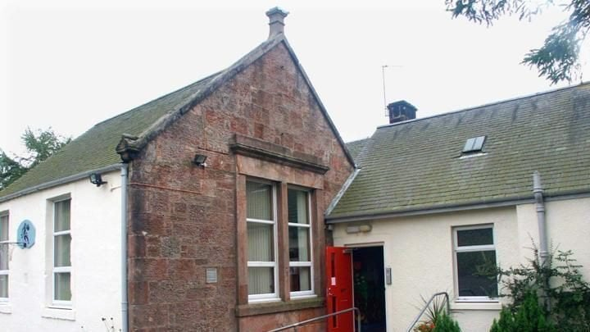

Background Information
Blairingone Primary School was declared surplus to requirements by Perth and Kinross (PKC) and closed in June 2019. The schoolhouse has been empty without any renovations since 2014.
The Council want to dispose of the property and negotiations have been underway within the Community about its future and possible Community Asset Transfer to the Fossoway Community Development Trust (FCDT) via lease or purchase.
The majority of the Blairingone community when surveyed supported the proposed CAT and initial CAT request forms were submitted to PKC in June 2023 with requests for funding for the required Business Plan.

We have now secured some funding for full and comprehensive consultation with the Fossoway community, especially the residents of Blairingone and surrounding hamlets, about their needs and requirements. The local elected members seem keen for community ownership and the FCDT, with the Blairingone subcommittee to run the school, are the best placed community organisation to take on this asset.

As a Trust we are interested in buying the property to transform the School into a Community meeting place for social events and fundraising activities such as ; Film Club, Community Café, Pudding Club, After School Club, Art Space, health and well -being activities, meetings for Community Council and other community groups and for hire for social events and parties.
The school has two main rooms each approx. 50m square, another room which used to be a kitchen although this has been taken out, toilets that are currently unusable and for children, storage, carpark, and outside garden grass area.
The Schoolhouse which is attached to the school could then be leased or hired out to provide an income to sustain the School and Trust. Options are; Health and well -being retreat to support carers in the community; Holiday let; Affordable homes in the rural area.

We need to know the views of everyone in the Fossoway area and especially the views of the residents of Blairingone and its surrounding hamlets. This asset will be primarily used by the locals, and it is the last remaining asset in the village of Blairingone;
It is not just for us but for our future generations.

Please complete the survey and any views or comments you have. You can complete form and give it to a member of sub-committee, drop it into the shop in either Crook of Devon or Powmill or email info@fossowaytrust.com before 30th April 2024
Sub Committee: Marion Anness, Karen Berwick, Joyce Hope, Jen Kennedy, Jane Pelly, Matthew Rice, Gil Vick

Survey Questions
- Which of the following activities do you think would benefit the Community at Blairingone Primary School and schoolhouse?

☐Community Events ☐Educational Workshops ☐Health and Wellbeing Activities
☐Art and Crafts Workshops ☐Cultural Events ☐Other – please specify

- Is it likely that you would be interested in attending Community activities?

☐ Very likely
☐ Likely
☐ Neither likely nor unlikely
☐ Unlikely
☐ Very Unlikely

- What type of activities might you be interested in?

- Do you have any other suggestions or ideas for other uses for the school and schoolhouse?

- Do you provide care for a loved one?
What activities would assist you in improving your health and well -being as carers?

- Any other comments?

Which village you live closest to.

☐ Blairingone ☐ Carnbo ☐ Crook of Devon ☐ Drum ☐ Powmill ☐ Rumbling Bridge

